The Road to the Texas Revolution
Accommodated Student Organizer: The Law of April 30, 1830

Instructions: The articles below are primary source excerpts directly from the Law of April 6, 1830. Using the guided questions, analyze each article through the perspective of a Mexican Citizen and new American Colonist living in Tejas (Texas). Answer each question using complete sentences and support your claim with text evidence.

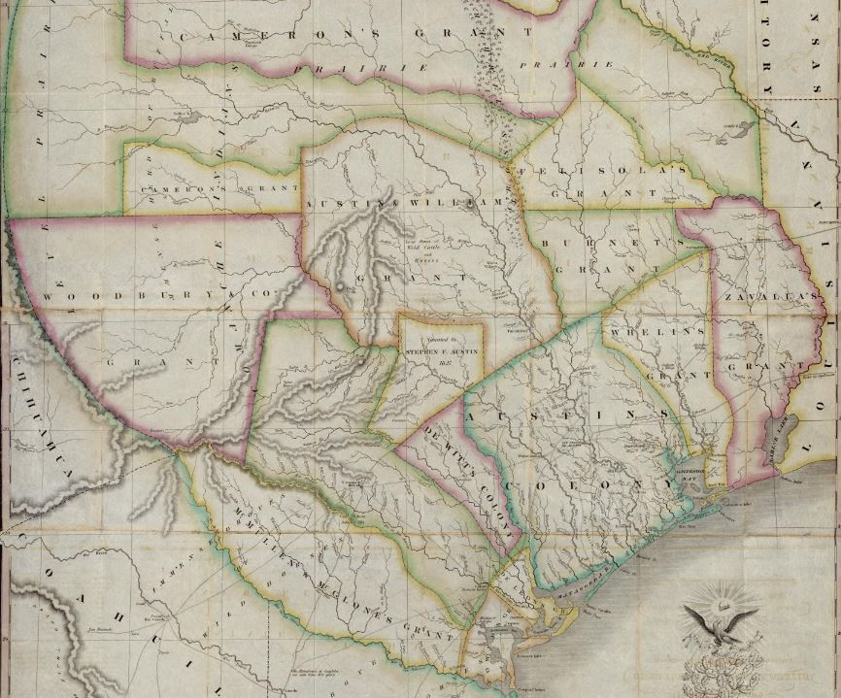
"Map of Texas with parts of the Adjoining States. Compiled by Stephen F. Austin.", map, Date Unknown; (https://texashistory.unt.edu/ark:/67531/metapth31277/: accessed September 8, 2021), University of North Texas Libraries, The Portal to Texas History, https://texashistory.unt.edu; crediting Star of the Republic Museum.

Article 3. The government is authorized to name one or more commissioners who shall visit the colonies of the frontier states and contract with the legislatures of said states for the purchase, in behalf of the Federal government, of lands deemed suitable for the establishment of colonies of Mexicans and other nationalities; and the said commissioners shall make, with the existing colonies, whatever arrangements seem expedient for the security of the republic.

Accommodated Summary of Article 3: The government is allowed to name one or more commissioners who will visit the colonies of the frontier states and contract with the leaders of those states for the purchase, in behalf of the Federal government, of lands that are good for the building of new colonies of Mexican and other nationalities; and those commissioners will make with the existing colonies an agreement quickly to secure the land for the Republic of Mexico.
Analysis Questions:
- In your opinion, what do you think the Mexican government's true intention was with Article 3?
The Mexican government’s true intention with Article 3 was
- What would the reaction of Mexican Citizens be to this new law? Explain your reasoning.
I think that the Mexican citizens would react to the new law by

because
- What would the reaction of American Colonists living in Texas be to this new law? Explain your reasoning.
I think that the American Colonists would react to the new law by

because
Article 7. Mexican families who voluntarily express a desire to become colonists will be furnished transportation, maintained for one year, and assigned the best of agricultural lands.

Accommodated Summary of Article 7: Mexican families who want to move to the colonies on the frontier will receive support in moving, support for one year, and will receive the best agricultural lands.
Analysis Questions:
- In your opinion, why do you think the Mexican government chose to add Article 7 to the Law of April 6?
The Mexican government added Article 7 because
- What would the reaction of Mexican Citizens be to this new law? Explain your reasoning.
I think that the Mexican citizens would react to the new law by

because
- What would the reaction of American Colonists living in Texas be to this new law? Explain your reasoning.
I think that the American Colonists would react to the new law by

because
Article 9. The introduction of foreigners across the northern frontier is prohibited under any pretext whatsoever, unless the said foreigners are provided with a passport issued by the agent of the republic at the point whence the said foreigners set out.

Accommodated Summary of Article 9: No foreigners are allowed in the Mexican frontier, unless the foreigner has a passport that was issued by an agent of the republic.
Analysis Questions:
- What was the purpose of Article 9?
The purpose of Article 9 was to
- What would the reaction of Mexican Citizens be to this new law? Explain your reasoning.
I think that the Mexican citizens would react to the new law by

because
- What would the reaction of American Colonists living in Texas be to this new law? Explain your reasoning.
I think that the American Colonists would react to the new law by

because
Article 10. No change shall be made with respect to the slaves now in the states, but the Federal government and the government of each state shall most strictly enforce the colonization laws, and prevent the further introduction of slaves.

Accommodated Summary of Article 10: No change will be made with respect to the slaves now in the states, but the Federal government and the government of each state will enforce the law that prevents the further introduction of slaves.
Analysis Questions:
- Why do you think the Mexican government wanted to “prevent the further introduction of slaves” as Article 10 states?
The Mexican government wanted to “prevent the further introduction of slaves” because
- What would the reaction of Mexican Citizens be to this new law? Explain your reasoning.
I think that the Mexican citizens would react to the new law by

because

- What would the reaction of American Colonists living in Texas be to this new law? Explain your reasoning.
I think that the American Colonists would react to the new law by

because

Article 11. In accordance with the right reserved by the general congress in the seventh article of the law of, August 18, 1824, it is prohibited that emigrants, from nations bordering on this republic shall settle in the states or territory adjacent to their own nation. Consequently, all contracts not already completed and not in harmony with this law are suspended.

Accommodated Summary of Article 11: Following the rights held by the government in the 7th article of the Law of August 18,1824 it is illegal that emigrants (people from other nations) bordering the Republic of Mexico can settle in the Mexican states or territory next to their own nation. This means that all contracts not completed that do not follow this law will be suspended.

Analysis Questions:
- What was the purpose of Article 11?
The purpose of Article 11 was to
- What would the reaction of Mexican Citizens be to this new law? Explain your reasoning.
I think that the Mexican citizens would react to the new law by

because

- What would the reaction of American Colonists living in Texas be to this new law? Explain your reasoning.
I think that the American Colonists would react to the new law by

because

Article 14. The government is authorized to expend five hundred thousand dollars
(pesos) in the construction of fortifications and settlements on the frontier; …

Accommodated Summary of Article 14: The government is authorized to spend $500,000 in the construction of forts and settlements on the frontier; ...
Analysis Question:
- What would the reaction of American Colonists living in Texas be to this new law? Explain your reasoning.
I think that the American Colonists would react to the new law by

because

