Road to the Texas Revolution
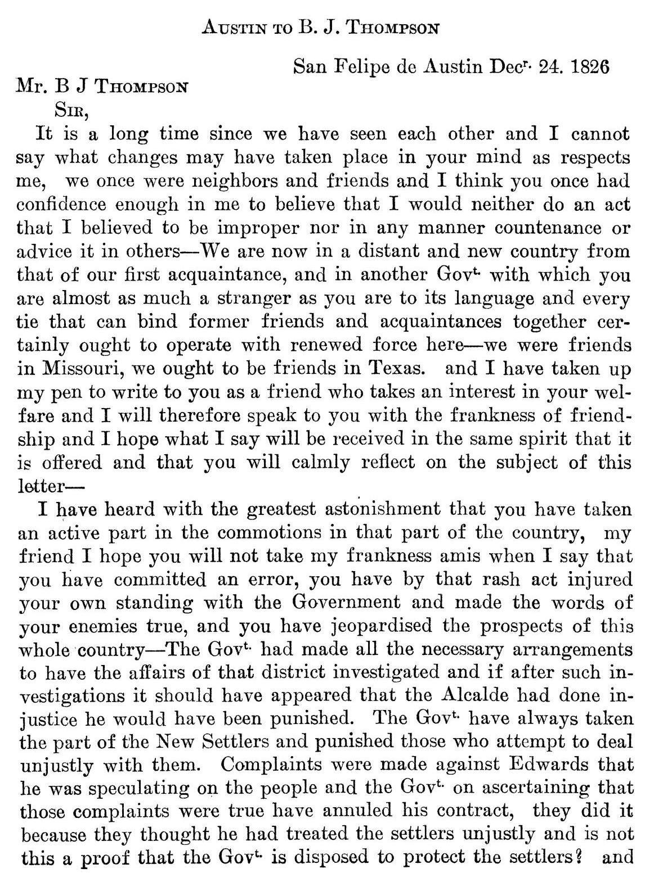
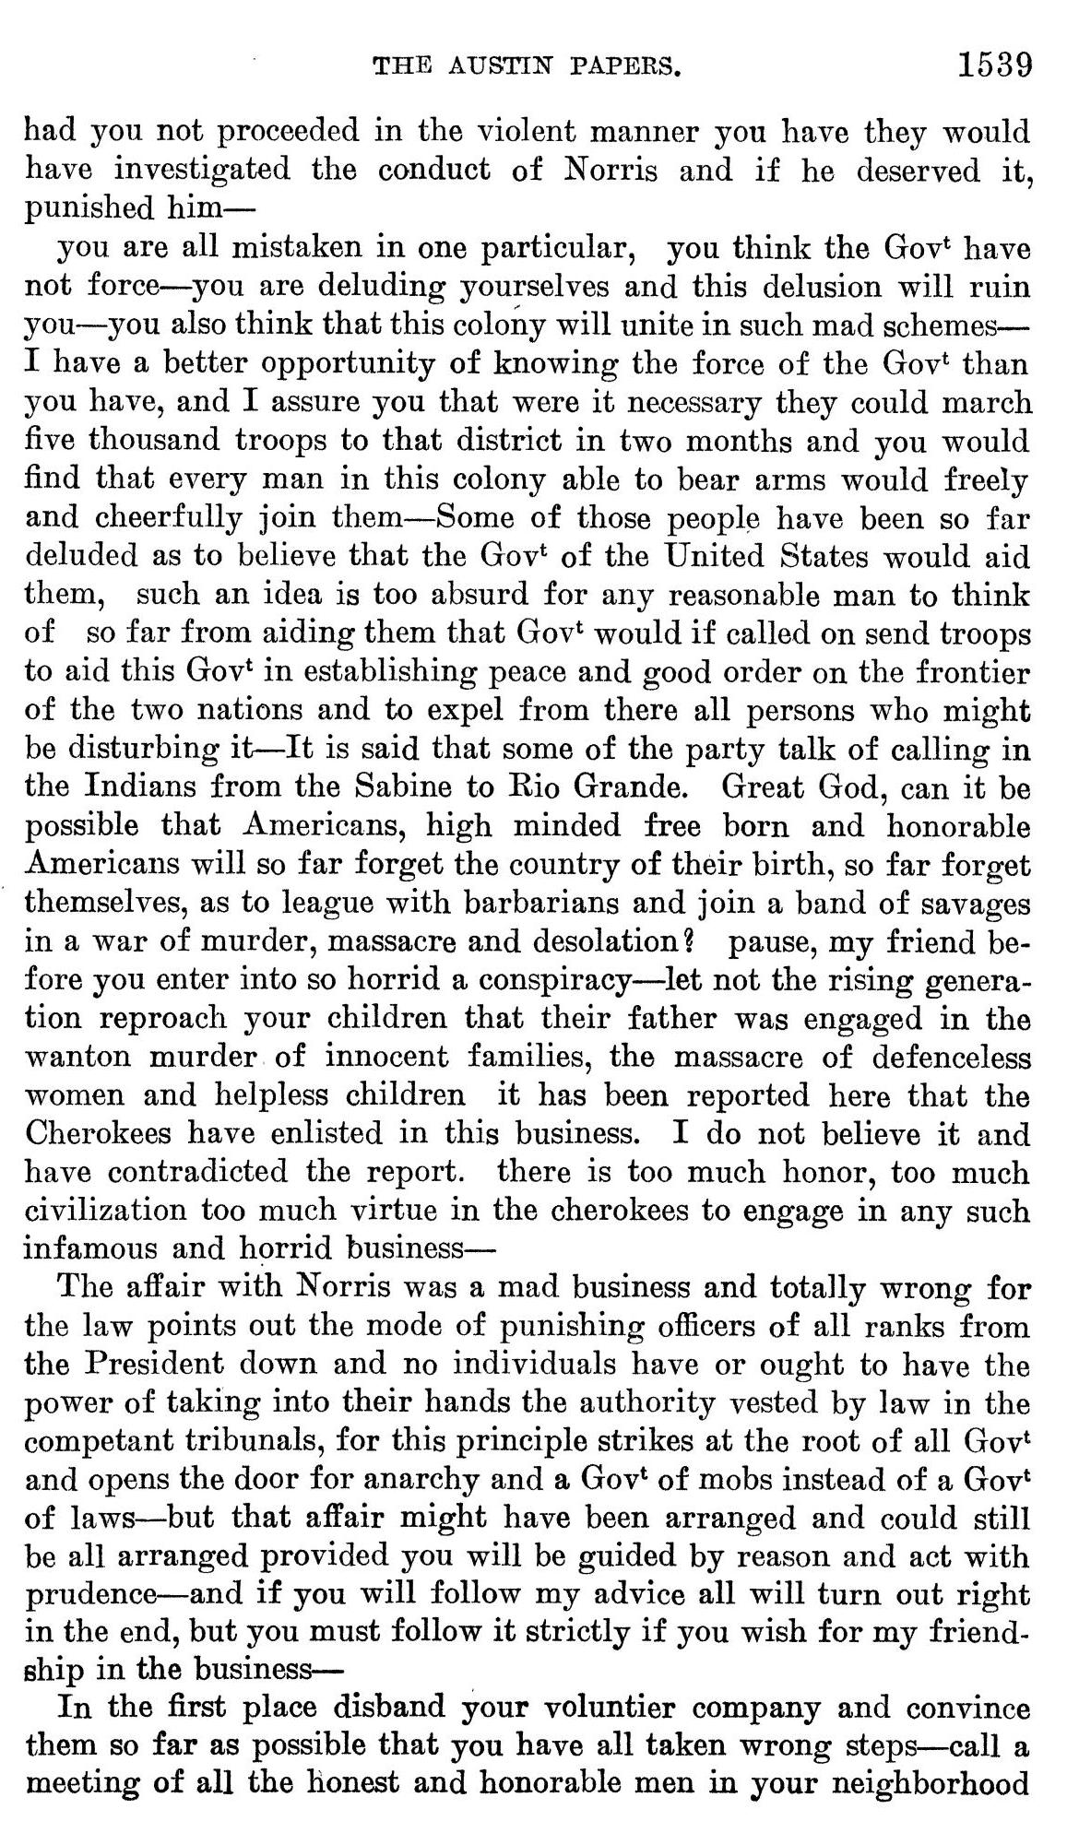
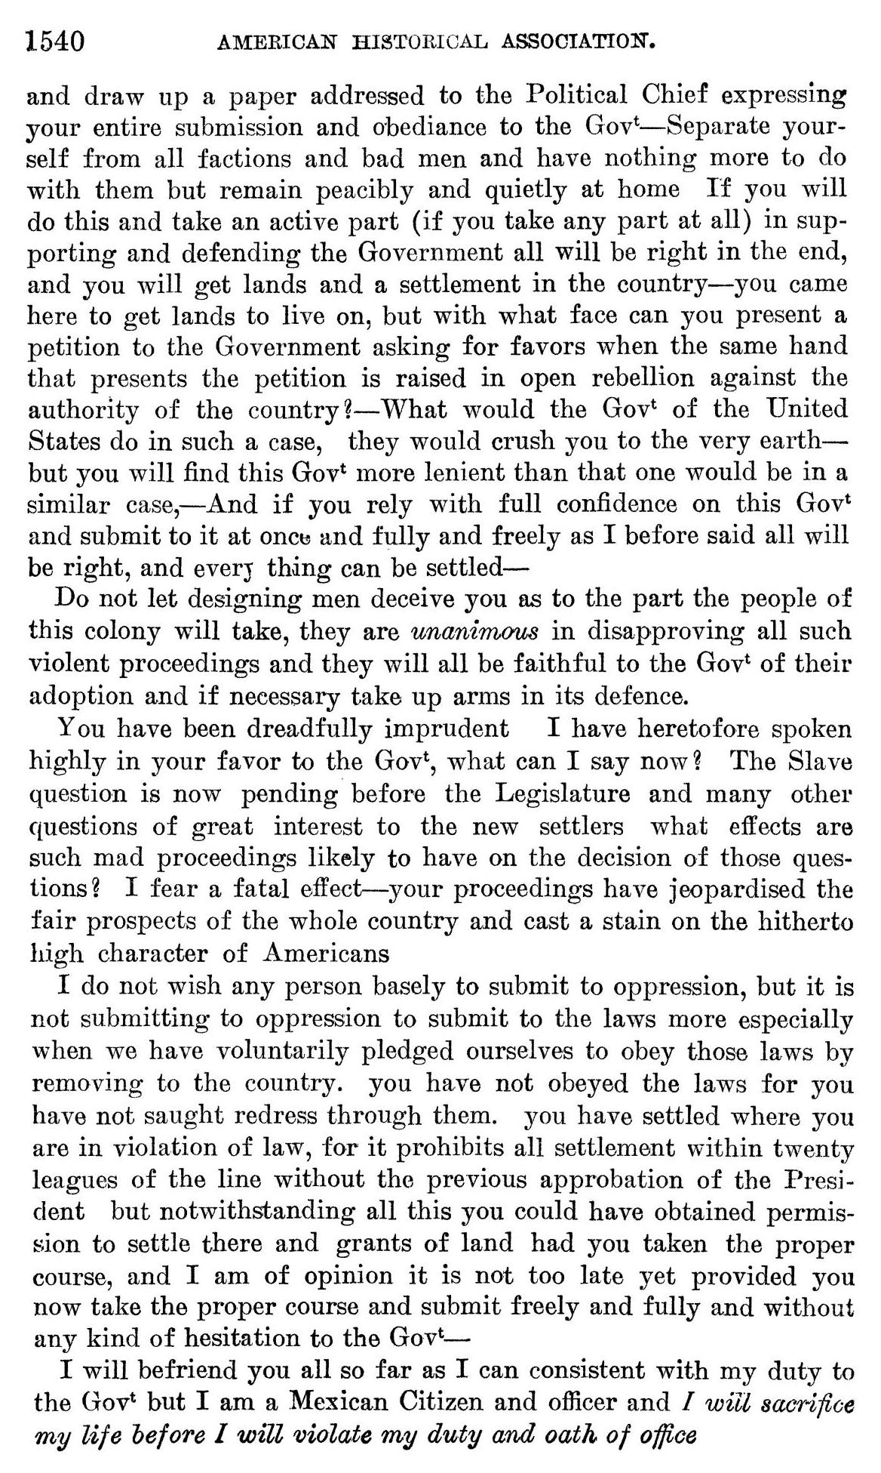
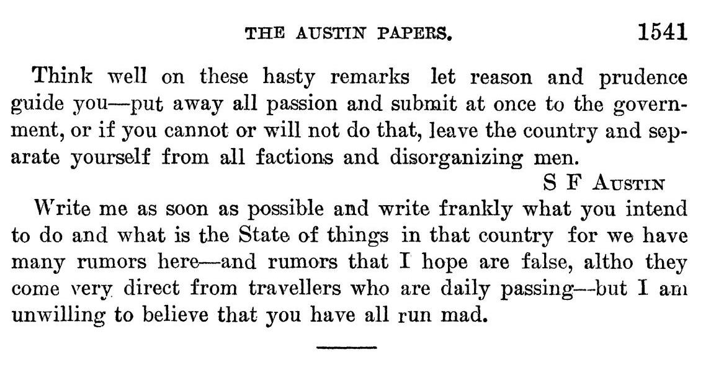
American Historical Association, and Eugene C. Barker. “Annual Report of the American Historical Association for the Year 1919: The Austin Papers in Two Volumes,” Volume 2, Part 2. The Portal to Texas History. United States. Government Printing Office., October 4, 2010. https://texashistory.unt.edu/ark:/67531/metapth121739/.

Transcriptions

Transcription of page 1538:

Austin to B. J. Thompson
San Felipe de Austin

December 24, 1826

Mr. B J Thompson

Sir,

It is a long time since we have seen each other and I cannot say what changes may have taken place in your mind as respects me, we once were neighbors and friends and I think you once had
confidence enough in me to believe that I would neither do an act that I believed to be improper nor in any manner countenance or advice it in others—We are now in a distant and new country from that of our first acquaintance, and in another Gov** with which you are almost as much a stranger as you are to its language and every tie that can bind former friends and acquaintances together certainly ought to operate with renewed force here—we were friends in Missouri, we ought to be friends in Texas, and I have taken up my pen to write to you as a friend who takes an interest in your welfare and I will therefore speak to you with the frankness of friendship and I hope what I say will be received in the same spirit that it is offered and that you will calmly reflect on the subject of this letter—

I have heard with the greatest astonishment that you have taken an active part in the commotions in that part of the country, my friend I hope you will not take my frankness amiss when I say that
you have committed an error, you have by that rash act injured your own standing with the Government and made the words of your enemies true, and you have jeopardised the prospects of this whole country—The Gov*- had made all the necessary arrangements to have the affairs of that district investigated and if after such investigations it should have appeared that the Alcalde had done injustice he would have been punished. The Gov. have always taken the part of the New Settlers and punished those who attempt to deal unjustly with them. Complaints were made against Edwards that he was speculating on the people and the Gov1, on ascertaining that
those complaints were true have annulled his contract, they did it because they thought he had treated the settlers unjustly and is not this a proof that the Gov*- is disposed to protect the settlers? and

Transcription of page 1539:

had you not proceeded in the violent manner you have they would have investigated the conduct of Norris and if he deserved it, punished him—

you are all mistaken in one particular, you think the Gov* have not force—you are deluding yourselves and this delusion will ruin you—you also think that this colony will unite in such mad schemes— I have a better opportunity of knowing the force of the Gov* than you have, and I assure you that were it necessary they could march five thousand troops to that district in two months and you would find that every man in this colony able to bear arms would freely and cheerfully join them—Some of those people have been so far deluded as to believe that the Gov* of the United States would aid them, such an idea is too absurd for any reasonable man to think of so far from aiding them that Gov* would if called on send troops to aid this Gov* in establishing peace and good order on the frontier of the two nations and to expel from there all persons who might be disturbing it—It is said that some of the party talk of calling in the Indians from the Sabine to Rio Grande. Great God, can it be possible that Americans, high minded free born and honorable Americans will so far forget the country of their birth, so far forget themselves, as to league with barbarians and join a band of savages in a war of murder, massacre and desolation? pause, my friend before you enter into so horrid a conspiracy—let not the rising generation reproach your children that their father was engaged in the wanton murder of innocent families, the massacre of defenceless women and helpless children it has been reported here that the Cherokees have enlisted in this business. I do not believe it and have contradicted the report, there is too much honor, too much civilization too much virtue in the cherokees to engage in any such infamous and horrid business—

The affair with Norris was a mad business and totally wrong for the law points out the mode of punishing officers of all ranks from the President down and no individuals have or ought to have the power of taking into their hands the authority vested by law in the competent tribunals, for this principle strikes at the root of all Gov* and opens the door for anarchy and a Gov* of mobs instead of a Gov* of laws—but that affair might have been arranged and could still be all arranged provided you will be guided by reason and act with prudence—and if you will follow my advice all will turn out right in the end, but you must follow it strictly if you wish for my friendship in the business—

In the first place disband your volunteer company and convince
them so far as possible that you have all taken wrong steps—call a meeting of all the honest and honorable men in your neighborhood

Transcription of page 1540:

and draw up a paper addressed to the Political Chief expressing your entire submission and obediance to the Gov*—Separate yourself from all factions and bad men and have nothing more to do with them but remain peacibly and quietly at home If you will do this and take an active part (if you take any part at all) in supporting and defending the Government all will be right in the end, and you will get lands and a settlement in the country—you came here to get lands to live on, but with what face can you present a petition to the Government asking for favors when the same hand that presents the petition is raised in open rebellion against the authority of the country?—What would the Gov* of the United States do in such a case, they would crush you to the very earth—but you will find this Gov1 more lenient than that one would be in a similar case,—And if you rely with full confidence on this Gov* and submit to it at once and fully and freely as I before said all will be right, and everything can be settled—

Do not let designing men deceive you as to the part the people of this colony will take, they are unanimous in disapproving all such violent proceedings and they will all be faithful to the Gov* of their adoption and if necessary take up arms in its defense.

You have been dreadfully imprudent I have heretofore spoken highly in your favor to the Gov*, what can I say now? The Slave question is now pending before the Legislature and many other
questions of great interest to the new settlers what effects are such mad proceedings likely to have on the decision of those questions? I fear a fatal effect—your proceedings have jeopardized the fair prospects of the whole country and cast a stain on the hitherto high character of Americans

I do not wish any person basely to submit to oppression, but it is not submitting to oppression to submit to the laws more especially when we have voluntarily pledged ourselves to obey those laws by removing to the country, you have not obeyed the laws for you have not sought redress through them, you have settled where you are in violation of law, for it prohibits all settlement within twenty leagues of the line without the previous approbation of the President but notwithstanding all this you could have obtained permission to settle there and grants of land had you taken the proper course, and I am of opinion it is not too late yet provided you now take the proper course and submit freely and fully and without any kind of hesitation to the Gov*—
I will befriend you all so far as I can consistent with my duty to the Gov* but I am a Mexican Citizen and officer and I will sacrifice my life before I will violate my duty and oath of office

Transcription of page 1541:

Think well on these hasty remarks let reason and prudence guide you—put away all passion and submit at once to the government, or if you cannot or will not do that, leave the country and separate yourself from all factions and disorganizing men.

S F Austin

Write me as soon as possible and write frankly what you intend to do and what is the State of things in that country for we have many rumors here—and rumors that I hope are false, although they come very direct from travelers who are daily passing—but I am unwilling to believe that you have all run mad.

