The Road to the Texas Revolution
Student Organizer: The Law of April 6, 1830
Articles of Change

Instructions: The articles below are primary source excerpts directly from the Law of April 6, 1830. Using the guided questions, analyze each article through the perspective of a Mexican Citizen and new American Colonist living in Tejas (Texas). Answer each question using complete sentences and support your claim with text evidence.

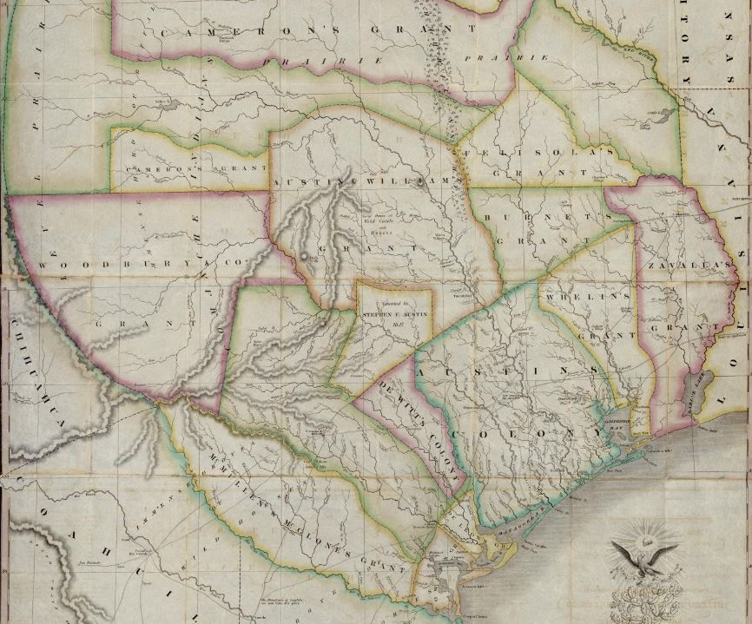
"Map of Texas with parts of the Adjoining States. Compiled by Stephen F. Austin.", map, Date Unknown; (https://texashistory.unt.edu/ark:/67531/metapth31277/: accessed September 8, 2021), University of North Texas Libraries, The Portal to Texas History, https://texashistory.unt.edu; crediting Star of the Republic Museum.

Article 3. The government is authorized to name one or more commissioners who shall visit the colonies of the frontier states and contract with the legislatures of said states for the purchase, in behalf of the Federal government, of lands deemed suitable for the establishment of colonies of Mexicans and other nationalities; and the said commissioners shall make, with the existing colonies, whatever arrangements seem expedient for the security of the republic.
Analysis Questions:
- In your opinion, what do you think the Mexican government's true intention was with Article 3?

- What would the reaction of Mexican Citizens be to this new law? Explain your reasoning.

- What would the reaction of American Colonists living in Texas be to this new law? Explain your reasoning.

Article 7. Mexican families who voluntarily express a desire to become colonists will be furnished transportation, maintained for one year, and assigned the best of agricultural lands.
Analysis Questions:
- In your opinion, why do you think the Mexican government chose to add Article 7 to the Law of April 6, 1830?

- What would the reaction of Mexican Citizens be to this new law? Explain your reasoning.

- What would the reaction of American Colonists living in Texas be to this new law? Explain your reasoning.

Article 9. The introduction of foreigners across the northern frontier is prohibited under any pretext whatsoever, unless the said foreigners are provided with a passport issued by the agent of the republic at the point whence the said foreigners set out.
Analysis Questions:
- What was the purpose of Article 9?

- What would the reaction of Mexican Citizens be to this new law? Explain your reasoning.

- What would the reaction of American Colonists living in Texas be to this new law? Explain your reasoning.

Article 10. No change shall be made with respect to the slaves now in the states, but the Federal government and the government of each state shall most strictly enforce the colonization laws, and prevent the further introduction of slaves.
Analysis Questions:
- Why do you think the Mexican government wanted to “prevent the further introduction of slaves” as Article 10 states?

- What would the reaction of Mexican Citizens be to this new law? Explain your reasoning.

- What would the reaction of American Colonists living in Texas be to this new law? Explain your reasoning.

Article 11. In accordance with the right reserved by the general congress in the seventh article of the law of, August 18, 1824, it is prohibited that emigrants, from nations bordering on this republic shall settle in the states or territory adjacent to their own nation. Consequently, all contracts not already completed and not in harmony with this law are suspended.
Analysis Questions:
- What was the purpose of Article 11?

- What would the reaction of Mexican Citizens be to this new law? Explain your reasoning.

- What would the reaction of American Colonists living in Texas be to this new law? Explain your reasoning.

Article 14. The government is authorized to expend five hundred thousand dollars
(pesos) in the construction of fortifications and settlements on the frontier; …
Analysis Question:
- What would the reaction of American Colonists living in Texas be to this new law? Explain your reasoning.

