 Warm-up: The Battle of San Jacinto Extension
Unit 5: The Texas Revolution
Name: |  | Date: |  | Period:

Observe the image and answer the question below. | “The Surrender of Santa Anna” by William Henry Huddle  The Library of Congress
What do you notice about the image?  How do you think this image is related to today’s lesson? | 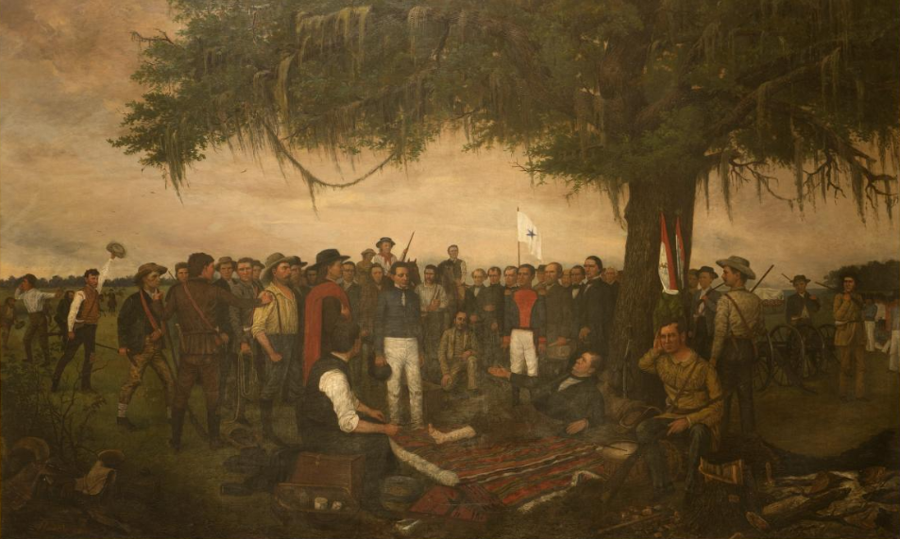

Warm-up: The Battle of San Jacinto Extension
Unit 5: The Texas Revolution
Name: |  | Date: |  | Period:

Observe the image and answer the question below. | “The Surrender of Santa Anna” by William Henry Huddle  The Library of Congress
What do you notice about the image?

How do you think this image is related to today’s lesson?


The Battle of San Jacinto Extension Exit Ticket

Directions: Complete the sentence stems below about the Battle of San Jacinto.
One important event that caused the Battle of San Jacinto was ____________________________________ ____________________________________ ____________________________________ ____________________________________ ____________________________________ | One important piece of information about the Battle of San Jacinto is _____________________ _____________________________________ _____________________________________ _____________________________________ _____________________________________ | One important effect of the Battle of San Jacinto was ________ _____________________________________ _____________________________________ _____________________________________ _____________________________________ _____________________________________

The Battle of San Jacinto Extension Exit Ticket

Directions: Complete the sentence stems below about the Battle of San Jacinto.
One important event that caused the Battle of San Jacinto was ____________________________________ ____________________________________ ____________________________________ ____________________________________ ____________________________________ | One important piece of information about the Battle of San Jacinto is _____________________ _____________________________________ _____________________________________ _____________________________________ _____________________________________ | One important effect of the Battle of San Jacinto was ________ _____________________________________ _____________________________________ _____________________________________ _____________________________________ _____________________________________

