 Warm-up: Texas Today
Unit 5: The Texas Revolution
Name: |  | Date: |  | Period:

Directions: Answer the questions based on your observations about the image below.

- What do you observe about this image?  - How do you think this image relates to the Texas Revolution and today’s lesson, “Texas Today?” | 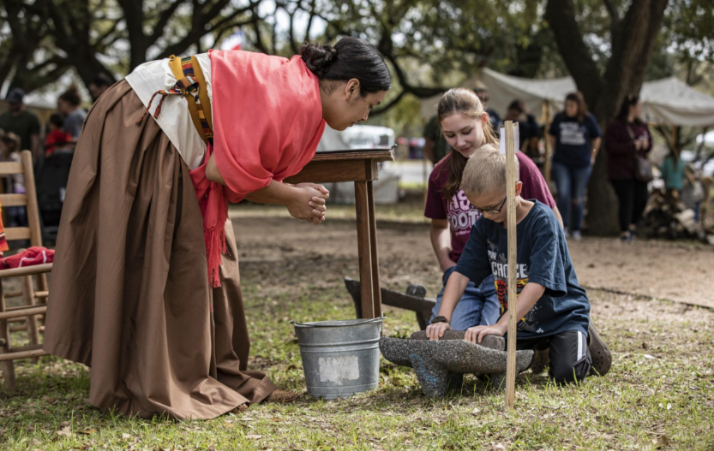

Warm-up: Texas Today
Unit 5: The Texas Revolution
Name: |  | Date: |  | Period:

Directions: Answer the questions based on your observations about the image below.

- What do you observe about this image?

- How do you think this image relates to the Texas Revolution and today’s lesson, “Texas Today?”


Texas Today Exit Ticket

Directions: Consider what you have learned about the historic site you researched in this lesson to answer the questions below.
How does the Texas Historical Commission work to preserve the history of your chosen historical site ? | How does the Texas Historical Commission work to educate the public about the history of your chosen historical site ?

Texas Today Exit Ticket

Directions: Consider what you have learned about the historic site you researched in this lesson to answer the questions below.
How does the Texas Historical Commission work to preserve the history of your chosen historical site ? | How does the Texas Historical Commission work to educate the public about the history of your chosen historical site ?

