# **The Big Picture *Advanced***

*Unit 5: The Texas Revolution*

|  |  |  |  |  |  |
| --- | --- | --- | --- | --- | --- |
| Name: |  | Date: |  | Period: |  |

**Part I: Analyze an Image**

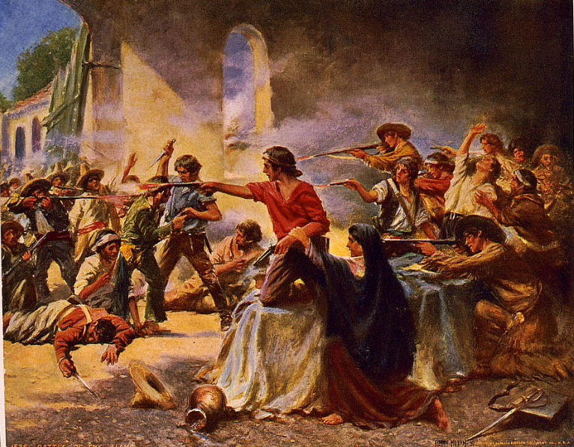

Figure : Battle of the Alamo, Percy Moran. ca. 1912. The Library of Congress

1. What are three things you observe about the image?
2. What are two things you can infer about this era of Texas history based on your observations?
3. What do you predict we will see in this unit based on the image?

**Part II: Essential Ideas Reading Passage**

In the previous unit, the Mexican National era, we saw tension increase in Texas and across Mexico following the centralist takeover of the federal government. The centralist government under President Antonio López de Santa Anna abolished the Federal Constitution of 1824. With this action the states lost power and people lost many of their rights. Federalist supporters across Mexico were deeply upset by this significant change. This included many Tejanos and Anglos in Texas.

A civil war broke out in several Mexican states like Zacatecas and Yucatán as federalists rebelled against the centralist takeover. At the same time, a centralist military general in San Antonio sent troops to Gonzales, Texas, to retrieve a cannon that the Mexican government had loaned to the citizens of Gonzales years earlier.

The people of Gonzales refused to return the cannon. Instead, they attacked the Mexican troops on October 2, 1835, causing them to retreat. This event became known as the Battle of Gonzales. With this fight, it seemed that Texas had entered the civil war on the side of the federalists.

As Texas entered the war, many did not agree on what they were fighting for, or if they should even be fighting at all. Almost everyone opposed the centralist takeover, but there were a lot of different opinions on what Texas should do about it. Many Tejano residents wanted to fight for federalism and restore the Constitution of 1824. Many long-time Anglo residents also wanted to restore the Constitution of 1824, but were very concerned that taking part in any war with Mexico would put their families, land, and businesses in jeopardy. Many newer Anglo arrivals, on the other hand, wanted to take part in the war, ***not*** to restore the constitution, but rather to gain Texas independence from Mexico.

Meanwhile, as Anglos and Tejanos struggled to organize, news of the rebellion in Texas reached Santa Anna and the centralist government in Mexico City. Eager to put down the Texas rebellion as quickly as possible, Santa Anna marched an army of 6,000 troops toward Texas in the middle of winter. What followed was a series of crushing defeats and losses for the inexperienced and disorganized Anglo and Tejano troops against the much stronger and more experienced Mexican army. Then, on April 21, 1836, the Texians encountered an opportunity at the San Jacinto River that would turn the tide of the war.

The fighting that took place from October 1835 to April 1836 came to be known as the Texas Revolution. The outcome of this war would have significant effects on Texas, the U.S., and Mexico during the years and decades that followed.

**Part III: Big Picture Comprehension Questions**

***Directions***: Use the reading passage on the previous page to answer the questions that follow.

1. Based on the Essential Ideas Reading passage on the previous page, what are the main ideas or primary characteristics of the Texas Revolution? Your response should be three to five sentences.

|  |
| --- |
|  |

1. Read each letter below showing the different points of view regarding the Texas Revolution. Then, write the letter for each point of view in the box under the correct group of people who held this viewpoint.
   1. “We should fight against the centralist government to restore the Federal Constitution of 1824.”
   2. “We support restoring the Federal Constitution of 1824; however, we are concerned that a war with the centralists could harm our businesses.”
   3. “We support a war against Mexico for the independence of Texas.”

|  |  |  |
| --- | --- | --- |
| Many newer Anglo arrivals to Texas | Many Anglos who had lived in Texas for years | Many Tejanos |
|  |  |  |

1. This question has two parts. Read the excerpt from *The Texas Republican* newspaper and answer the questions that follow.

|  |
| --- |
| “…Information which is relied on, has been received from the Interior, that the states of Zacatecas and Guadalaxara[*sic*[1]] have risen and taken up arms in defence[*sic*] of the Constitution of 1824, & in support of the Federal system: also, that there are insurrections in the state of Tamaulipas, in favor of the same cause: also, that the republican general Juan Alvarez, has gained a victory over the government troops in the south of Mexico. All these, and all the freemen of Mexico, are now fighting for the same cause that the people of Texas are defending. It is the cause of freedom--it is holy and just, and must triumph.”   * *The Texas Republican* (Brazoria, Texas) pp.2. Vol. 1, No. 56, Ed. 1. Published October 10, 1835 |

**Part A**

What is this author’s point of view?

* 1. The author supports the federalist rebellions against the centralist government.
  2. The author opposes the federalist rebellions against the centralist government.
  3. The author supports Santa Anna’s centralist government and believes the rebellions are illegal.
  4. The author opposes the Texians who are fighting for independence from Mexico.

**Part B**

Which excerpt from the article provides evidence to support your answer to Part A?

1. “…also, that there are insurrections in the state of Tamaulipas, in favor of the same cause…”
2. “All these, and all the freemen of Mexico, are now fighting for the same cause that the people of Texas are defending. It is the cause of freedom--it is holy and just, and must triumph.”
3. “Information which is relied on, has been received from the Interior, that the states of Zacatecas and Guadalaxara[*sic*] have risen and taken up arms in defence[*sic*] of the Constitution of 1824.”
4. “…also, that the republican general Juan Alvarez, has gained a victory over the government troops in the south of Mexico”

1. [*sic*] is often used to show that the author misspelled the word he or she wrote or spelled it differently from today’s spelling standards.