**The Big Picture *Grade Level***

*Unit 5: The Texas Revolution*

|  |  |  |  |  |  |
| --- | --- | --- | --- | --- | --- |
| Name: |  | Date: |  | Period: |  |

**Part I: Analyze an Image**

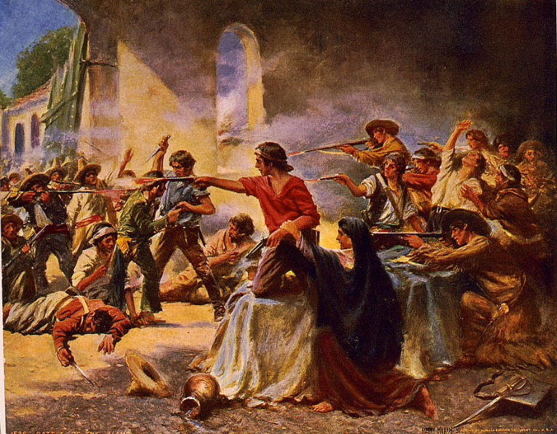

Figure : Battle of the Alamo, Percy Moran. ca. 1912. The Library of Congress

1. What are two things you observe about this image?
2. What can you infer about this era of Texas history based on your observation?
3. What do you predict we will see in this unit based on the image?

**Part II: Essential Ideas Reading Passage**

In the last unit, we learned about the Mexican National era when tension grew in Texas and Mexico after the centralists took over the federal government. Under President Antonio López de Santa Anna, the centralists ended the Federal Constitution of 1824. This change caused the states to lose power and the people to lose rights. Supporters of federalism in Mexico, including many Tejanos and Anglos in Texas, were very upset.

A civil war broke out in some Mexican states like Zacatecas and Yucatán as federalists fought the centralist takeover. In San Antonio, a centralist general sent some soldiers to Gonzales, Texas. His goal was to retrieve a cannon that the Mexican government had lent the citizens of Gonzales a few years before.

The people of Gonzales refused to return the cannon. Instead, they fought the soldiers on October 2, 1835, forcing them to retreat. This fight was called the Battle of Gonzales. It seemed to show that Texas was joining the civil war on the federalists' side.

As Texas entered the war, many people disagreed on why they were fighting or if they should fight at all. Almost everyone in Texas was against the centralist takeover, but there were several different opinions on what Texas should do about it. Many Tejanos wanted to fight for federalism and to bring back the Constitution of 1824. Many Anglos who had lived in Texas for a long time also wanted this, but they worried about how a war could affect their businesses. Many new Anglo settlers wanted to fight for total independence from Mexico.

As Tejanos and Anglos tried to organize, news of the rebellion reached Santa Anna’s centralist government in Mexico City. He marched 6,000 soldiers to Texas in the middle of winter to stop the rebellion as quickly as possible. Santa Anna’s centralist troops were much more experienced and well-organized than the Anglo and Tejano forces. The Texas troops faced many challenges and defeats as Santa Anna pursued them across Texas. However, on April 21, 1836, at the San Jacinto River, the Texas troops would have an opportunity that changed the war.

The battles from October 1835 to April 1836 are known as the Texas Revolution. The results of this war greatly affected Texas, the U.S., and Mexico for years to come.

**Part III: Big Picture Comprehension Questions**

***Directions***: Use the reading passage on the previous page to answer the questions that follow.

1. Based on the Essential Ideas Reading passage on the previous page, how would you characterize the Texas Revolution era? Your response should be two to three sentences.

|  |
| --- |
| The Texas Revolution era is characterized by _______________________________________ ____________________________________________________________________________________________________________________________________________________________________________________________ One example that supports this claim is ________________________________________________ ______________________________________________________________________________________________ |

1. Read each letter below showing the different points of view regarding the Texas Revolution. Then, write the letter for each point of view in the box under the correct group of people who held this viewpoint.
   1. “We should fight against the centralist government to restore the Federal Constitution of 1824.”
   2. “We support restoring the Federal Constitution of 1824; however, we are concerned that a war with the centralists could harm our businesses.”
   3. “We support a war against Mexico for the independence of Texas.”

|  |  |  |
| --- | --- | --- |
| Many newer Anglo arrivals to Texas | Many Anglos who had lived in Texas for years | Many Tejanos |
|  |  |  |

1. This question has two parts. Read the excerpt from *The Texas Republican* newspaper and answer the questions that follow.

|  |  |
| --- | --- |
| “…Information which is relied on, has been received from the **Interior**, that the states of Zacatecas and Guadalaxara[*sic*[1]] have risen and **taken up arms** in defence[*sic*] of the Constitution of 1824, & in support of the Federal system: also, that there are **insurrections** in the state of Tamaulipas, in favor of the same cause: also, that the republican general Juan Alvarez, has gained a victory over the government troops in the south of Mexico. All these, and all the freemen of Mexico, are now fighting for the same cause that the people of Texas are defending. It is the cause of freedom--it is holy and **just**, and must **triumph**.”   * *The Texas Republican* (Brazoria, Texas) pp.2. Vol. 1, No. 56, Ed. 1. Published October 10, 1835 | **Interior:** the center of the country  **Taken up arms:** started fighting  **Insurrections**: rebellions  **Just**: Fair  **Triumph**: Succeed, win |

**Part A**

What is this author’s point of view?

* 1. The author supports the federalist rebellions against the centralist government.
  2. The author opposes the federalist rebellions against the centralist government.
  3. The author supports Santa Anna’s centralist government and believes the rebellions are illegal.
  4. The author opposes the Texians who are fighting for independence from Mexico.

**Part B**

Which excerpt from the article provides evidence to support your answer to Part A?

1. “…also, that there are insurrections in the state of Tamaulipas, in favor of the same cause…”
2. “All these, and all the freemen of Mexico, are now fighting for the same cause that the people of Texas are defending. It is the cause of freedom--it is holy and just, and must triumph.”
3. “… that the states of Zacatecas and Guadalaxara[*sic*] have risen and taken up arms in defence[*sic*] of the Constitution of 1824.”
4. “…also, that the republican general Juan Alvarez, has gained a victory over the government troops in the south of Mexico”

1. [*sic*] is often used to show that the author misspelled the word he or she wrote, or spelled it differently from today’s spelling standards.