Name: | Date: | Class/Period:

African Americans in the Texas Revolution (Accommodated):
The Story of Joe

Instructions: Analyze the primary source documents by answering the questions using supporting evidence.

Background Essay
Joe, who was enslaved to William B. Travis, was the only adult male to survive the assault of the Alamo by Mexican forces led by Santa Anna on March 6, 1836. Joe’s survival offers some of the most critical accounts of the fighting. Joe arrived in Texas in 1832 – 1833 and was sold at a public auction in 1835 to William B. Travis. Joe arrived at the Alamo when Travis took over command there in February 1836.
The oral accounts of Joe’s experience while at the Alamo provide a firsthand account of the final hours in the Alamo, in From Virginia to Texas, 1835 Diary of Col. William F. Gray. Joe gave an interview to the Texas Cabinet that included in attendance Tejano leaders such as Francisco Ruiz, Jose Antonio Navarro, and Lorenzo de Zavala. Joe detailed the last few hours inside the Alamo. According to William F Gray, Joe “related the affair with much modesty [humility], apparent candor [honest], and remarkably distinctive [high quality of character].”
According to Joe, early Saturday morning, the Mexican Army attacked, and hearing screams outside, “Travis sprang up, seized his rifle and sword, and called to Joe to follow him. Joe took his gun and followed. Travis ran across the Alamo and mounted the wall and called out to his men, “Come on, boys, the Mexicans are upon us.” He discharged his gun; so did Joe. In an instant, Travis was shot down. He fell within the wall, on sloping ground, and sat up.” The first two attack waves with scaling ladders were defeated by the Texans; in the third attempt, the Mexican soldiers poured over the Alamo walls. Soon the fighting turned into hand-to-hand combat, fighting from room to room. “As Travis sat wounded on the ground, General Mora, who was passing him, made a blow at him (Travis) with his sword, which Travis struck up, and ran his assailant through the body with his sword, and both died on the same spot.”
After the battle, a Mexican soldier called out for survivors, and Joe stepped out and was almost killed; Captain Bargen quickly stepped in to save Joe, and took him to Santa Anna. Later Santa Anna questioned Joe on the size of the Texas Army and if more soldiers were coming from the United States. Next, Joe was “shown an impressive display of the Mexican troops in the hope that he would return to the Texas army and tell them that any further resistance to such a superior force would be futile.”

Analysis Questions:
- Considering the quote from William F Gray ``related the affair with much modesty [humility], apparent candor [honesty], and remarkably distinctive [high quality of character].” In your opinion, do you believe the Tejanos and Anglo-Americans view Joe differently?
I believe that the Tejanos and Anglo Americans viewed Joe differently/the same (circle one) because
- According to Joe’s account, how did Travis die? How does that differ from what history has shown you?
According to Joe, Travis died by

This is different from other histories because
- Do you find Joe's account (of the events of the Battle of the Alamo) to be believable? Why or why not?
I believe/do not believe (circle one) Joe’s account because
- Why was it important for Santa Anna to show Joe the size of the Mexican Army?
I think it was important for Santa Anna to show Joe the size of the army because

Document A, Fifty Dollars for a Runaway Slave
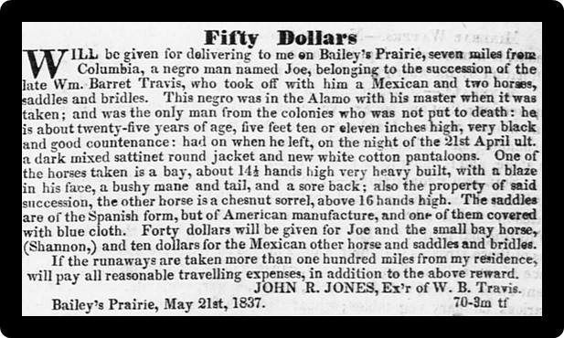
Jones, John R. “Fifty Dollars.” Telegraph and Texas Register, May 26 – August, 1837.
After the death of Travis at the Alamo, Joe was turned over to the executor of Travis's estate, John R. Jones. An executor of an estate is someone who manages the affairs of the deceased person. Jones then leased out Joe's time to anyone who would pay for it, so Joe ended up doing work for various folks under Jones's direction.
“Penniless and homeless, Joe sought employment in Washington on the Brazos and eventually went to work for John R Jones, the executor of Travis’ estate.” Soon the relationship between the two soured, and Joe, along with another worker, decided to leave. Above is an advertisement published in local newspapers to locate a runaway enslaved person during the early to mid-1800s.
Hansen, Todd. The Alamo Reader: A Study in History. Stackpole Books, 2003. Pp. 77-86

Analysis Questions:
- Using the advertisement above do you think Joe actually stole the horses and the equipment? Why or why not.
I think that Joe did/did not (circle one) steal the horses and equipment because
- Considering William F Gray’s quote on how he viewed Joe “related the affair with much modesty [humility], apparent candor [honest], and remarkably distinctive [high quality of character].” Do you think John R. Jones views Joe differently?
I think that John R. Jones views Joe the same/different (circle one) than Gray because
Conclusion
To be fair, “the horses, saddles, and bridles were part of the late Colonel Travis’ estate; as the only Texas survivor of the estate, Joe could hardly be labeled a thief for using the horses, especially when one learns of his destination.” Several weeks after Joe left, “he arrived on foot at the Travis family home in Conecuh County, Alabama. He had lost or abandoned the horse and the Mexican companion at some early point in his journey.” The Travis family historian notes that Joe “claimed to have walked all the way from Texas to Conecuh County, to have had to swim the Mississippi river and endure many hardships to bring the tale of Travis' death to his people. The family here received the first news of the Alamo” from Joe. This trip would have been over 800 miles from Washington on the Brazos in Texas to Conecuh County, Alabama would have taken Joe months to travel.

Hansen, Todd. The Alamo Reader: A Study in History. Stackpole Books, 2003. Pp. 77-86

Analysis Questions:
- Based on this account, do you think Joe was actually a thief? Cite your evidence.
Based on this account I think that Joes was/was not (circle one) a thief, because
- Considering the geographic terrain of the Gulf Coastal Plains of Texas that extend through Louisiana and into Alabama, explain what Joe would have faced in his 800-mile journey home.
On his journey home, Joe would have faced

