Name: | Date: | Class/Period:

American Indians in the Texas Revolution:

Accommodated Hook Exercise – Comanche Attack 1836
Instructions: Analyze the primary source newspaper account of a Comanche attack and answer the reflection question below.
Background: The headwaters where the river or creek begins on the Navidad River is approximately 10 miles southwest of present-day La Grange, Texas. At the time this area was part of Stephen F. Austin’s empresario grant.
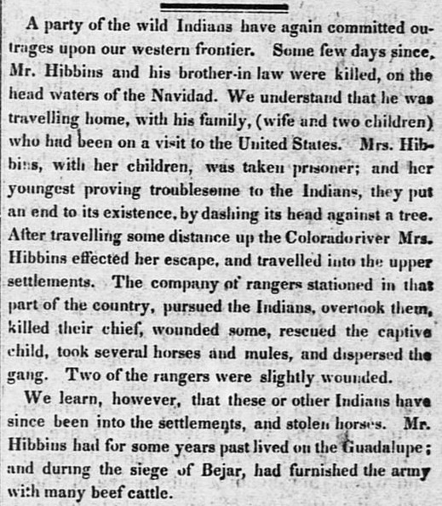
Telegraph and Texas Register (San Felipe de Austin [i.e. San Felipe], Tex.), Vol. 1, No. 17, Ed. 1, Saturday, February 27, 1836 Page: 2 of 8 https://texashistory.unt.edu/ark:/67531/metapth47887/
Transcript of the newspaper article:
“A party of wild Indians have again committed outrages upon our western frontier. Some few days since Mr. Hibbins and his brother-in law were killed, on the head waters of Navidad. We understand that he was traveling home, with his family, (wife and two children) who had been on a visit to the United States. Mrs. Hibbins, with her children, was taken prisoner; and her youngest providing troublesome to the Indians, they put an end to its existence, by dashing its head against a tree. After travelling (sic) some distance up the Colorado river Mrs. Hibbins effected [made] her escape, and travelled (sic) into the upper settlements. The company of rangers stationed in that part of the country, pursued the Indians, overtook them, killed their chief, wounded some, rescued the captive child, took several horses and mules, and dispersed the gang. Two of the rangers were slightly wounded.
We learned, however, that these or other Indians have since been into the settlements and stolen horses. Mr. Hibbins had for some years past lived on the Guadalupe; and during the siege of Bejar, had furnished the army with many beef cattle.”
Analysis Questions
- According to the newspaper account, this attack was on a family returning home, what provoked the attack in your opinion?
I think the attack started because
- How does this account portray the American Indians?
American Indians are portrayed as

