Name: | Date: | Class/Period:

Voices: American Indians in the Texas Revolution

A Tejano Living Among the Comanches (Accommodated)

Instructions: Read the background information and analyze primary source excerpts to answer the questions using supporting evidence.

Background Information:
On the outskirts of the frontier Texas town of Laredo, a young boy named Macario Leal, just 13 years of age, encountered a Comanche raiding party while working in his mother’s fields. Along with Macario, two other young relatives were surprised to learn of a Comanche raiding party that captured Macario, killing another relative.

The Comanches and other Plains Indians benefitted from Mexico’s instability, which often “hinders the ability of northern Mexicans to defend themselves and the central government’s capacity to provide military support.” This lack of military support permitted the Comanches to travel freely and raid with impunity. During the 1840s and 1850’s the “Comanches and their allies spent long periods raiding and trading south of the Rio Grande, operating often from hideouts” deep in the Chihuahuan Desert. The raiding strengthened the Comanche trading networks that reached as far north as Santa Fe and extended south of the Big Bend Region.

Macario witnessed the killing and scalping of his older brother, and while in captivity, Macario experienced beatings and intimidation. Life as a Comanche captive was tough. Shortly after being captured, Macario was tied to a horse that he had little control over. On his first night, the Comanche horse herd became spooked and began stampeding. Macario, who was still tied to his horse, became separated from his Comanche captors in the stampede. When his Comanche captors located Macario, he was scolded and beaten because they thought he tried to escape. The beatings of captives were “rites of passage, reinforcing the abductees’ dependency on their captors,” and it positioned them at the lowest level of Comanche society.

Macario lived with the Comanche until 1854, when he escaped and turned himself into a military official in Monterrey. He was quickly interrogated about his time living among the Comanche. Macario’s interrogation gives us insight into the Comanche culture, and “it contains a wealth of information on pre-reservation Comanche culture, particularly on Comanche captivity-related behavior, raiding, and trading practices.” The documents are taken directly from his interrogation; Macario verbally responds to questions from the Mexican official.

Rivaya-Martínez, Joaquín. “The Captivity of Macario Leal: A Tejano among the Comanches, 1847–1854.” Southwestern Historical Quarterly, vol. 117, no. 4, Apr. 2014, pp. 372–402., doi:10.1353/swh.2014.0043.
Document A, Why did Comanches Use Violence so Often?
“Comanche campaign [raids] at all times, preferring the summer because of the ease they then have to fatten up their horses. To invite others to go on the campaign, they play drum music, and dance around a hide that they hit with little sticks. . . Once they have gathered, they march daily until they reach the place that they want to harry [attack], taking every opportunity that presents itself along the way to exercise their barbarity [raiding and killing]... They [Americans] wage war on us [Comanche] because we do not want to make peace with them, and either they will destroy us or their race will disappear.”
Rivaya-Martínez, Joaquín. “The Captivity of Macario Leal: A Tejano among the Comanches, 1847–1854.” Southwestern Historical Quarterly, vol. 117, no. 4, Apr. 2014, pp. 372–402., doi:10.1353/swh.2014.0043.

Analysis Questions:

- What reasoning do the Comanche have when Macario states, “we do not want to make peace with them, and either they will destroy us or their race will disappear?”

The Comanche people believe the Americans want to
- Are the Comanche justified in their beliefs towards Anglo-Americans? Please cite contextual evidence.

The Comanche believe that

Comparison of Two Journal Entries

Document B, How were captives treated?
David Burnet to John Jamison, writing from Nacogdoches, August 1818 | The Captivity of Macario Leal: A Tejano among the Comanches, 1847–1854
“If a captive survived the “severe initiation” of the first days in camp, he was “afterward exempt from corporal punishment . . . considered a member of their society, and . . . attached as a slave to the family of the warrior who captured him, where he is generally treated with humanity.” | “Upon arrival, they took him down from the horse, stripped him, and he began to suffer the torment inflicted by the Indians, who beat him, torturing him to such a degree that he came to believe that they would kill him.”  “Every night, when the Indians went to sleep, they tied deponent’s [Macario] hands behind him, tying his feet with a mecate [rope] that they threw over a tree, raising half of his body so that he was left resting only on his back.”
“David G. Burnet's Letters Describing the Comanche Indians.” West Texas Historical Association Year Book, vol. 30, Oct. 1954, pp. 130. | Rivaya-Martínez, Joaquín. “The Captivity of Macario Leal: A Tejano among the Comanches, 1847–1854.” Southwestern Historical Quarterly, vol. 117, no. 4, Apr. 2014, pp. 372–402., doi:10.1353/swh.2014.0043.

Analysis Questions:

- After reading Macario’s account, is his account confirming David G. Burnet’s account? Please use text evidence to support your response.
Macario was

which confirms Burnet’s account.

- Using the background information, why did the Comanche beat their captives? Please use text evidence to support your response.
The Comanche treated captives as

Document C, Comanche Shield
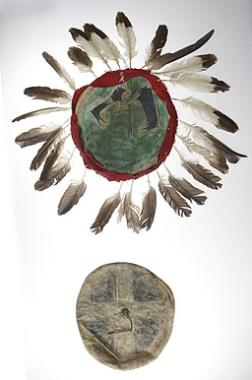 | “The shield is a defensive weapon to which they offer much veneration [respect]. When they are not fighting they keep it perfectly covered, even more eagerly in times of rain to protect it from the water. They make it from bison hide, which they stretch out perfectly they sprinkle it with boiling water. They cover it with buckskin, celebrating this operation with a ritual dance. Its shape is circular, about three spans in diameter. They fix a strip or hoop to the back, through which they pass the arm to protect themselves from the shots fired at them. . . Each Indian paints an animal head on his shield using red paint. Others attach to the shield the preserved animal head. They think that the animal they have chosen is the one that has the power to protect them from the gunshots that they receive in the shield.”
Rivaya-Martínez, Joaquín. “The Captivity of Macario Leal: A Tejano among the Comanches, 1847–1854.” Southwestern Historical Quarterly, vol. 117, no. 4, Apr. 2014, pp. 372–402., doi:10.1353/swh.2014.0043.
Photo Source Unknown Author, Public domain, via Wikimedia Commons, https://commons.wikimedia.org/wiki/File:Native_American_Shield_and_Cover,_Comanche.jpg
Analysis Questions:

- Why do you think the Comanche warrior’s shield is so important to them?

The Comanche warrior believes the shield is
- Is the animal image placed on the shield something more than an image?

Yes, because a Comanche warrior believes the animal they have chosen
- The shield is made of animal hide. Do you believe that it can actually protect the Comanche warrior?
I believe the shield, can/cannot (choose one) protect them because

Document C, Comanche Bow and Lance
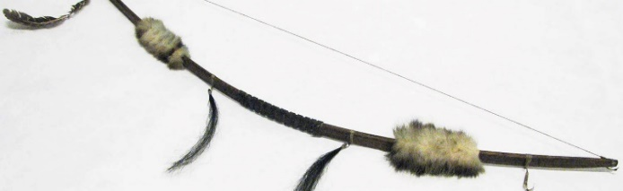 | 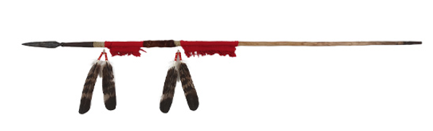

“Their usual weapons are the bow and arrow and the lance, and some of them use the rifle. They make their bows out of cat's-claws [a hardwood tree found in the desert of northern Mexico]. They prepare it by rubbing it with fat and leaving it in the sun. They make the string of deer or cow sinew [animal tendon], and they only string the bow when they need to use it. They make their lances [pike] of a verduguillo [spearhead] perfectly sharpened with two edges, and three spans long [nine inches], which they secure to a strong shaft.

To prevent them from cracking, they commonly fix them with a strip or ferrule of silver to secure the part where the spear point joins the shaft. They acquire these kinds of weapons as well as rifles at San Carlos, New Mexico, and the Colorado River, paying for them with coins, or with the processed hides that they obtain in their hunts.”
Rivaya-Martínez, Joaquín. “The Captivity of Macario Leal: A Tejano among the Comanches, 1847–1854.” Southwestern Historical Quarterly, vol. 117, no. 4, Apr. 2014, pp. 372–402., doi:10.1353/swh.2014.0043.
Photo Source, “Comanche Hunting Bow, via Bob Bullock Museum, https://www.thestoryoftexas.com/discover/artifacts/comanche-hunting-bow
Photo Source, “Comanche Lance”, via Bob Bullock Museum, https://www.thestoryoftexas.com/discover/artifacts/comanche-lance

Analysis Questions:

- Macario notes that “Their usual weapons are the bow and arrow and the lance, and some of them use the rifle.” Why do you think the Comanche prefer these over the rifle?
These weapons are
- To someone being attacked by a Comanche warrior, which would be more fearsome, being shot at a distance by a rifle or up close by the bow and arrow or a lance?
I believe being attacked, from a distance/up close (circle one) to be scarier because

Document D, Games the Comanche Play
Their games are horse races, ball games, and tórpetit. They play the ball with some curved sticks [that they use like a racket], which have a flat surface and a convex [curved]. Women play it with their feet. The tórpetit consists of eight short semi-cylindrical sticks, in the middle of the sticks’ a flat surface, that they paint in red, painting some black dots on the edges. They use these sticks like dice, throwing them, and counting the number of points added by all of the sticks that fall with the grooved surface up.”
Rivaya-Martínez, Joaquín. “The Captivity of Macario Leal: A Tejano among the Comanches, 1847–1854.” Southwestern Historical Quarterly, vol. 117, no. 4, Apr. 2014, pp. 372–402., doi:10.1353/swh.2014.0043.

Analysis Questions:

- What game do you think the ball game is known as today?
They are playing
- From your prior knowledge about the Comanche people, would you have believed they played games? Explain your reasoning.
I believe/would not believe (circle one) Comanche played games
- Considering that the Comanche play games and socialize, does this characterization differ from how history portrays them? Explain your answer.
History has portrayed American Indians like the Comanche

