Name: | Date: | Class/Period:

American Indians in the Texas Revolution:

Hook Exercise – Comanche Attack 1836
Instructions: Analyze the primary source newspaper account of a Comanche attack and answer the reflection question below.
Background: The headwaters, where the river or creek begins on the Navidad River is approximately 10 miles southwest of present-day La Grange, Texas. At the time this area was part of Stephen F. Austin’s empresario grant.
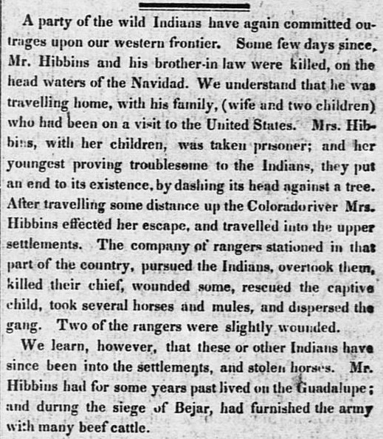
Telegraph and Texas Register (San Felipe de Austin [i.e. San Felipe], Tex.), Vol. 1, No. 17, Ed. 1, Saturday, February 27, 1836 Page: 2 of 8 https://texashistory.unt.edu/ark:/67531/metapth47887/
Analysis Questions
- According to the newspaper account, this attack was on a family returning home, what provoked the attack in your opinion?

- The article mentions “Two of the rangers were slightly wounded” what can you infer about this group of men, what was their job?

- How does this account portray the American Indians?

- Are the American Indians the only ones committing “outrages upon our western frontier?” Support your response with evidence from the account.

