Name: | Date: | Class/Period:

Voices: Women in the Texas Revolution
Susanna Dickinson: Background Essay
Instructions: Read the background information and answer the analysis questions.

Often referred to as the only survivors of the Battle of the Alamo, Susanna (and her daughter Angelina) Dickinson’s story continues far beyond the Alamo walls. Susanna (Wilkerson) was a native of Tennessee and, at the age of seventeen, she and her husband, Almaron Dickinson, moved to Gonzales, Texas in late February, 1831. As new members of Green DeWitt’s Colony, Almaron was given one league of land (equal to 4,428.4 acres) to settle along the San Marcos river. The couple opened a masonry shop and became accustomed to the painstaking work of frontier life. A few years later, on December 14, 1834, the Dickinson’s welcomed their only child, Angelina. Because of their homestead location, Almaron was involved in the battle of Gonzales on October 2, 1835, the first skirmish of the Texas Revolution. Soon after the battle was over, most of the men from the colony joined other Texian volunteers under the command of Stephen F. Austin and left for San Antonio. Susanna, just as many other women in the colony, was left alone with a baby to maintain their home, taking on all of her husband's responsibilities.
By December of 1835 she and Angelina joined her husband and the other Texian volunteers in San Antonio. On February 23, 1836, the Dickinson family, along with other women, children, and Texian volunteers retreated to the Alamo to endure the 13-day siege. After the Battle of the Alamo on the morning of March 6, 1836, Susanna and Angelina, along with “upwards of a dozen” other Tejano women, children, and African American men were taken by Mexican soldiers into San Antonio to be interviewed by General Santa Anna. Various accounts state that Santa Anna sent each woman away with two pesos and a blanket. Many of the survivors returned to their family home in or near San Antonio, however, without her husband, Susanna had no family to return to. In a later interview, Susanna recounted that Santa Anna offered to take Angelina back to Mexico to which Susanna refused. He then gave her a message to deliver to Sam Houston, warning Texans that the fate of the Alamo defenders would be the fate of anyone who opposed him. She then began her journey to Gonzales (about 75 miles from San Antonio) with two escorts from the Mexican Cavalry who deserted her just outside of San Antonio. Alone, exhausted, and grieved Susanna and Angelina made the long trek with few resources. Along the way, she was joined by Joe (Colonel Travis’ enslaved servant) who had survived the battle and then escaped eastward. Together, they made their way to General Houston and delivered the message. Houston then ordered a strategic retreat and burned the town of Gonzales to prevent it from falling into Santa Anna’s hands. The American colonists in the area abandoned their homes and also began retreating east to escape from Santa Anna in what became known as the “Runaway Scrape.” Susanna’s home in Gonzales was burned and she had no choice but to escape eastward with the Texas Army, with nothing left of her own except her baby daughter in her arms.
Following the Texas Revolution, Susanna moved to the new town of Houston where she received no financial support from the newly formed Republic of Texas despite her many requests and pleas. With no means of providing for her daughter, Susanna found herself in and out of abusive marriages until she met and married her fifth (and final) husband, Joseph William Hanning (who was 20 years her junior). The couple settled in Austin and established a very prominent cabinet/furniture business. It was there where Susanna enjoyed a comfortable lifestyle and the security of a prosperous marriage. The Hannings were married for 26 years until Susanna’s death on October 7, 1883.
Scheer, Mary L. Women and the Texas Revolution. University of North Texas Press, 2012.
Hansen, Todd, Morphis, James M., and John E. Elgin. The Alamo Reader: A Study in History. Stackpole Books, 2003, Pp. 45–69.

Background Essay Analysis Questions:

- As a young bride at the age of 17, what do you think Susanna’s initial reaction was to the news of moving to Texas to colonize? Explain your reasoning.
- What type of hardships might Susanna and other women new to the Texas frontier have faced in their daily lives as colonists?
- How do you think Susanna felt when Almaron left her and their baby alone in Gonzales to go to San Antonio? Explain your reasoning.
- Why do you think Santa Anna gave every woman who survived the Battle of the Alamo two pesos and a blanket before he sent them away? Explain your reasoning.
- Out of all Susanna’s accounts in the Texas Revolution mentioned above, which one seems the most frightening? Explaining your reasoning.

- In your opinion, why do you think Susanna chose to stay in Texas after the Revolution ended?

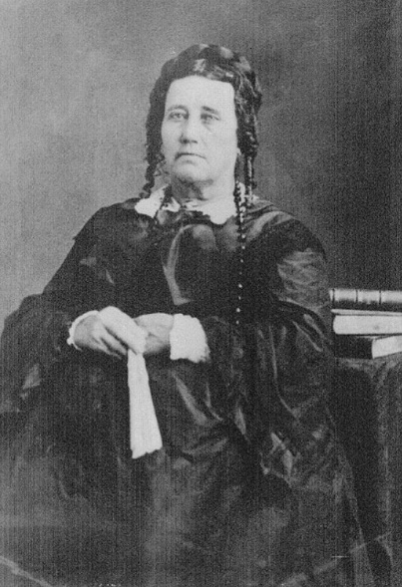
Susanna Wilkerson Dickinson. Texas State Library and Archives.

