|  |
| --- |
| **1)The Battle of Gonzales – October 2, 1835**  **Advanced** |

In 1831, **Green DeWitt’s** Anglo colony at **Gonzales** requested a cannon from Mexico to provide protection against American Indian attacks. Then in 1835, civil war broke out in Mexico as federalists rebelled against the centralist takeover of the government. The Mexican military leader stationed in San Antonio, **Colonel Domingo de Ugartechea**, thought it unwise to allow the people of Gonzales to keep the cannon. He requested they return it. But the people of Gonzales refused.

Ugartechea sent 100 dragoons, or cavalry soldiers, to retrieve the cannon. The people of Gonzales called for reinforcements from the surrounding area. Approximately 140 Texians formed a **militia**, or a fighting force made up of volunteers. The Gonzales militia attacked the dragoons when they arrived, forcing them to retreat to San Antonio.

**The Battle of Gonzales** appeared to be part of the larger national conflict between federalists and centralists at the time. It seemed that Texas had entered the civil war on the side of the federalists. Today, we consider the Battle of Gonzales the first battle of the Texas Revolution.

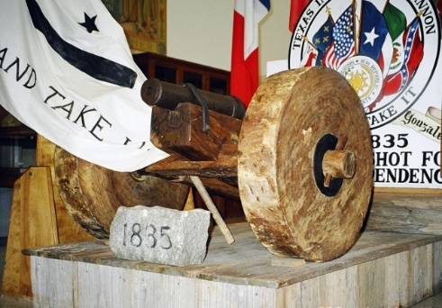

Figure 1 The Gonzales cannon

|  |
| --- |
| **2)The Consultation – November 1835**  **Advanced** |

Following the Battle of Gonzales, Texian delegates held a meeting known as **“the Consultation”** in the town of San Felipe de Austin to discuss what to do next. Should Texas go to war with Mexico? If so, what would Texas be fighting for? A return to the Federal Constitution of 1824, or total independence from Mexico?

There was no consensus among the delegates on these questions at the Consultation. They weren’t certain if they should fight or what exactly they would be fighting for. Regardless, they were still able to make a few significant decisions.

One important decision they made about the war was to call for the establishment of a militia and a regular army. **Sam Houston** was unanimously chosen to command the army of Texas and granted the rank of Major General.

The delegates were also able to make some significant political decisions. They declared their support for the **Federal Constitution of 1824 and** created a provisional government for Texas based on key principles of that document.

They also stated that because Santa Anna had abolished that constitution, the people of Texas had the right to declare independence if they chose. Yet they did **NOT** declare independence at this time. They just wanted to state that they *could* if they wanted.

Ultimately, the Consultation failed to make many clear decisions, and the provisional government they established held very little power.

|  |
| --- |
| **3) The Alamo – February 23 to March 6, 1836**  **Advanced** |

The delegates at the Consultation were concerned about the large number of centralist troops stationed in **San Antonio** under the command of **General Martín Perfecto de Cos**. In December 1835, Texas troops marched to San Antonio where they were able to drive Cos and his men out of the city after a five-day street battle.

When President Santa Anna learned of the growing rebellion in Texas, he gathered an army of nearly 6,000 soldiers and led them to Texas himself to stop the rebellion. When he and his army arrived in San Antonio in February 1836, he surprised the Anglos and Tejanos in town. They had not expected a swift military response during the middle of a harsh winter. The Anglo and Tejano troops, along with some citizens of San Antonio, sought refuge at an old Spanish mission on the outskirts of town. It was called the **Alamo**

Santa Anna’s forces quickly surrounded the Alamo, bombarding the structure constantly for thirteen days. During the **Siege of the Alamo**, a small number of Texan volunteers were able to sneak through Santa Anna’s lines and into the Alamo to reinforce the soldiers inside.

Then, in the early morning of March 6, Santa Anna’s army attacked. All of the men defending the Alamo were killed. Some civilians (people who were not fighting) survived.

News of the **Battle of the Alamo** soon spread through Texas. When Texans learned that Santa Anna’s army was now heading east toward them, many began abandoning their farms and homes looking for safety.

|  |
| --- |
| **4) The Constitutional Convention of 1836**  **Advanced** |

During the Siege of the Alamo, delegates from Texas held another meeting known as the **Constitutional Convention of 1836.** The convention began on March 1 at a place called **Washington-on-the-Brazos**. An Anglo delegate named **George Childress** was in charge of a committee that wrote the Texas Declaration of Independence. On March 2, 1836, the delegates officially declared Texas free from Mexico.

The delegates elected an Anglo man named **David G. Burnett** as the president of the provisional (or temporary) government of the Republic of Texas. A Mexican delegate named **Lorenzo de Zavala,** who helped **Childress** write the Texas Constitution, was named the new vice-president of Texas. The delegates also officially named **Sam Houston** as Commander-in-Chief of all the military forces of Texas.

The Constitutional Convention of 1836 lasted about two weeks. During that time, they received news about the fall of the Alamo and that Santa Anna’s army was now marching east in pursuit of Sam Houston’s army. The Convention disbanded and the delegates fled for safety on March 17, 1836.

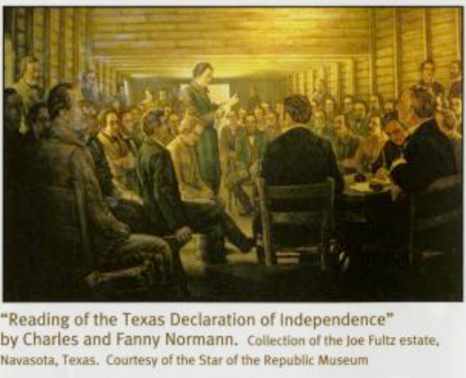

Figure 2: The Constitutional Convention of 1836, The Portal to Texas History

|  |
| --- |
| **5) The Runaway Scrape – March to April 1836**  **Advanced** |

As Santa Anna’s army crossed into Texas many Texans began packing their belongings in a fearful rush to escape Santa Anna’s oncoming troops. As Santa Anna approached San Antonio, many residents of that town also fled for safety.

**Sam Houston** and his troops were in **Gonzales** on March 11, when he received word that the **Alamo** had fallen five days earlier. Santa Anna’s army of 6,000 was reported to be marching toward Gonzales.

Houston knew he did not yet have enough soldiers to defeat Santa Anna, so he ordered the evacuation of Gonzales and led his army east away from Santa Anna’s oncoming forces. With the Texas army retreating, people in the area feared there was nothing to protect them from Santa Anna’s oncoming soldiers, and so many began abandoning their farms to flee to safety.

This mass movement of the Texas military and citizens, as well as the enslaved people who were forced on the journey, all trying to flee Santa Anna’s oncoming army came to be known as the **Runaway Scrape**.

Thousands of Texas refugees traveled east in freezing temperatures as they faced challenges like muddy roads, spreading diseases, and a lack of shelter and supplies like food or medicine. Those who died during the Runaway Scrape were often buried where they fell.

The Runaway Scrape continued until the final battle of the war on April 21, 1836 – the Battle of San Jacinto.

|  |
| --- |
| **6) The Goliad Massacre – March 27, 1836**  **Advanced** |

Normally in a war, soldiers who surrender are held as prisoners of war and not to be harmed. After the Battle of Gonzales, the centralist government passed the **Decree of December 30, 1835**. This order stated that all foreigners who fought against the government were to be treated as pirates and executed, even if they surrendered. Santa Anna strictly enforced this order throughout the Texas Revolution.

On March 20, 1836, Colonel James W. Fannin was forced to surrender approximately 300 men to General José de Urrea at the Battle of Coleto Creek. Urrea then marched the prisoners-of-war to **Goliad** and held them in the chapel of the old Spanish mission at **La Bahía**. More captured Texian soldiers from Refugio were also brought to La Bahía as prisoners-of-war.

Colonel Urrea wrote to Santa Anna requesting mercy for Fannin and his men. Santa Anna, however, ordered the immediate execution of the prisoners.

Bound to obey Santa Anna’s orders, the Mexican troops under Urrea executed nearly 400 of the prisoners in the nearby woods on March 27, 1836. Some of the Texans were spared for various reasons, while a handful of others escaped. A Tejana woman named **Francita Alavez** helped save the lives of some others. She has come to be known as the “Angel of Goliad.”

The Goliad Massacre terrified many Texans. A lot of people began to abandon their homes to flee for safety during the Runaway Scrape.

|  |
| --- |
| **7) The Battle of San Jacinto – April 21, 1836**  **Advanced** |

After the fall of the Alamo, Santa Anna rushed his troops east toward Sam Houston’s forces at **Gonzales**. Sam Houston knew his army was not yet ready for a direct confrontation with Santa Anna’s larger army, so he ordered his men to continue their retreat east to gain more reinforcements and training.

Santa Anna was eager to find a fast way to end the rebellion in Texas. When he reached the Brazos River, Santa Anna decided to move quickly ahead with only 750 soldiers to try to capture the Texas government.

He marched as fast as he could toward the San Jacinto River, leaving the rest of his soldiers behind. When Sam Houston learned about this, he realized this was the chance the Texian army had been waiting for.

Houston raced toward the **San Jacinto River** and arrived on April 20, 1836. Santa Anna and his army arrived later. Santa Anna then received about 400 reinforcements, bringing his total numbers to 1,200 troops. Houston’s army was only slightly smaller with about 900 soldiers.

On the afternoon of April 21, Houston ordered his men to attack Santa Anna’s army. Sam Houston’s army defeated Santa Anna in only 18 minutes. The killing continued for hours, however, as Mexican soldiers retreated or surrendered. Santa Anna was captured the following day and forced to surrender.

With this Anglo and Tejano victory, the Texas Revolution was over.

|  |
| --- |
| **8) The Treaties of Velasco – May 14, 1836**  **Advanced** |

Texan soldiers captured Santa Anna on April 21, 1836. He was kept as a prisoner at **Fort Velasco on the Texas coast**. Then, on May 14, 1836, he signed the two **Treaties of Velasco** with the provisional Texas president**, David G. Burnett**. One treaty was immediately made public. The other was kept secret until the terms of the public treaty were fulfilled.

The public treaty called for an end to the war. It demanded that the Mexican army withdraw from Texas and not return.

In the secret treaty, the Texas government promised to free Santa Anna on the condition that he use his political power to ensure that the Mexican government recognize Texas independence. Santa Anna also had to promise to remove his army and not take up arms against Texas in the future.

The secret treaty also required Santa Anna to work for a good political relationship between Texas and Mexico, and – most important -- it set the border between Texas and Mexico at the Rio Grande River.

While the Treaties of Velasco are seen to have ended the Texas Revolution, Mexico refused to recognize the legitimacy of the treaties or Texas independence. They argued that Santa Anna had not signed the treaties freely, but rather as a prisoner of the Texans.