|  |
| --- |
| **1)The Battle of Gonzales – October 2, 1835**  **Foundations** |

In 1831, the people of **Gonzales** requested a **cannon** from Mexico. They hoped it would provide protection against American Indian attacks. Then, in **1835**, centralists took over the federal government, and **federalist rebellions broke out across Mexico**.

**Colonel Domingo de Ugartechea** of the Mexican military didn’t think it was a good idea to let the people of Gonzales to keep the cannon. He asked that they return the cannon, however, **the people of Gonzales refused.**

Ugartechea sent 100 soldiers to take the cannon back. The people of Gonzales called for **reinforcements** from the surrounding area. About 140 Texians formed a **militia**, **or a volunteer group of fighters.** The Gonzales militia attacked the Mexican soldiers, forcing them to retreat to San Antonio.

Many people at the time believed that this battle showed that the Texans were joining the civil war on the side of the federalists. **Today, we consider the Battle of Gonzales the first battle of the Texas Revolution.**

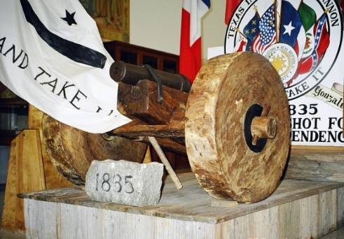

Figure 1 The Gonzales cannon

|  |
| --- |
| **2) The Consultation – November 1835**  **Foundations** |

After the Battle of Gonzales, **Texian delegates** held a **meeting** at **San Felipe de Austin**. This meeting was known as “**the Consultation**.” **The purpose of the meeting was to discuss what to do next**. Should Texas go to war with Mexico? If so, what would Texas be fighting for? Did they want to return to the Federal Constitution of 1824?  Or did they want total independence from Mexico?

**The delegates could not agree on these questions at the Consultation.** They weren’t certain if they should fight or what exactly they would be fighting for. Even so, they were still able to make a few significant decisions.

One important decision they made about the war was to **establish a militia and a regular army**. **Sam Houston** was unanimously chosen to **command the army of Texas**. He was granted the rank of Major General.

The delegates were also able to make some significant political decisions. **They declared their support for the Federal Constitution of 1824.** They created a **provisional government** for Texas based on key principles of that document.

They also stated **that they had the right to declare independence if they chose** because Santa Anna had abolished the Constitution of 1824. They did **NOT** actually declare independence at this time, however.

Ultimately, the Consultation failed to make many clear decisions, and the provisional government they established held very little power.

|  |
| --- |
| **3) The Alamo – February 23 to March 6, 1836**  **Foundations** |

**There were a lot of centralist troops stationed in San Antonio in 1835**. This worried delegates at the Consultation. They sent the **militia** to **San Antonio** to fight the army under **General Martín Perfecto de Cos.** In December 1835, **Texas troops were able to force General Cos and his men out of the city** after five days of fighting.

**President Santa Anna** learned of the growing rebellion in Texas. He gathered an army of **6,000 soldiers** and led them to Texas himself to stop the rebellion. He and his army arrived in **San Antonio** in **February 1836**, taking the Anglos and Tejanos by surprise. They had not expected Santa Anna to make the difficult journey to Texas during the middle of a harsh winter. **The Anglo and Tejano troops and some citizens of San Antonio fled to an** **old Spanish mission on the outskirts of town. It was called the Alamo.**

Santa Anna’s army **surrounded** the Alamo, **bombing** the structure constantly for **thirteen days.** During the **Siege of the Alamo**, a small number of Texan forces were able to sneak through Santa Anna’s lines to **reinforce** the soldiers inside.

Then, in the early morning of **March 6, Santa Anna’s army attacked**. **All of the men defending the Alamo were killed.** Some civilians (people who were not fighting) survived.

News of the Alamo spread through Texas. When people learned that Santa Anna was heading east toward them, **many began abandoning the farms and homes looking for safety.**

|  |
| --- |
| **4) The Constitutional Convention of 1836**  **Foundations** |

During the **Siege of the Alamo**, delegates from Texas held another **meeting** known as the **Constitutional Convention of 1836**. The convention began on **March 1** at a place called **Washington-on-the-Brazos.** An Anglo delegate named **George Childress** was in charge of a committee that wrote the **Texas Declaration of Independence**. Texas was now officially stating it wanted to be free from Mexico.

The delegates formed a **provisional**, or temporary, government called the **Republic of Texas.** They elected an Anglo man named **David G. Burnett** as the provisional president. A Mexican delegate named **Lorenzo de Zavala** helped **Childress** write the **Texas Constitution**. Zavala was also named the new Vice President of Texas. The delegates officially named **Sam Houston** **Commander-in-Chief of the Republic of Texas’ military.**

The **Constitutional Convention of 1836** lasted approximately two weeks. During that time, they received word of **the fall of the Alamo**, and they learned that Santa Anna’s army was quickly marching in their direction. **The Convention ended and the men fled for safety on March 17, 1836.**

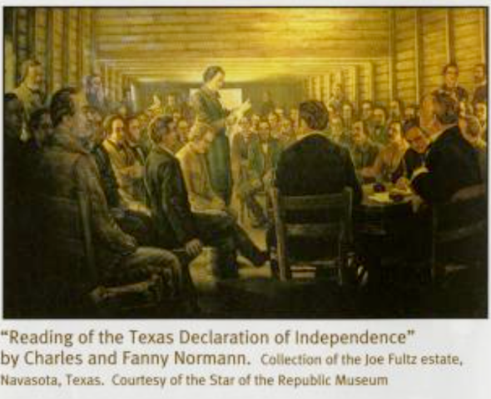

Figure 2 The Constitutional Convention of 1836, The Portal to Texas History

|  |
| --- |
| **5) The Runaway Scrape – January to April 1836**  **Foundations** |

When news reached Texas about Santa Anna’s army approaching in January 1836, **many Texans began fearfully packing their belongings to seek refuge, or safety, from Santa Anna’s oncoming troops**. As Santa Anna approached San Antonio, many residents of that town also **fled for safety**.

**Sam Houston** and his troops were in **Gonzales** on **March 11**, when he found out that the Alamo had fallen**.** **Santa Anna’s army was reported to be marching toward Gonzales.**

Houston knew he did not have enough soldiers yet to defeat Santa Anna. He ordered the **evacuation** of the town and led his army east away from Santa Anna’s approaching troops. The people in the area were afraid that no one would be able to protect them from Santa Anna now that the Texas army was leaving. Many people began abandoning their farms and homes and fleeing east as well.

**This mass movement of the Texas army and citizens, as well as enslaved people who were forced on the journey, all fleeing Santa Anna is known as the Runaway Scrape.**

Thousands of Texas **refugees** traveled **east** in freezing temperatures. They faced **challenges** like muddy roads, disease, and a lack of shelter and supplies like food or medicine. Many people died on the journey.

The **Runaway Scrape** continued until the final battle of the war on **April 21, 1836** – **the Battle of San Jacinto.**

|  |
| --- |
| **6) The Goliad Massacre – March 27, 1836**  **Foundations** |

Normally in war, if soldiers surrender, they are kept as prisoners of war and shouldn’t be hurt by the enemy. After the **Battle of Gonzales**, the centralist government passed the **Decree of December 30, 1835.** This legal order stated that **all foreigners who fought against the government would be executed,** even if they surrendered. Santa Anna strictly enforced this order during the Texas Revolution.

On **March 20, 1836**, an Anglo colonel named **James W. Fannin** surrendered approximately 300 men to **General José de Urrea** during the Battle of **Coleto Creek.**

 Urrea marched the **prisoners-of-war** to **Goliad** and held them in the chapel of the **old Spanish mission at La Bahía.** More captured soldiers from the Battle of Refugio were also brought to La Bahía as prisoners-of-war.

**Colonel Urrea wrote** **to Santa Anna requesting mercy for Fannin’s troops.** Santa Anna, however, ordered the immediate **execution of the prisoners.**

**Urrea’s troops followed Santa Anna’s order and executed nearly 400 of the prisoners on March 27, 1836**. Some were spared. Some escaped the execution. A Tejana woman named **Francita Alavez** helped save the lives of some others. She has come to be known as the **“Angel of Goliad.”**

The **Goliad Massacre** troubled many Texans, and many began to join the large groups of people fleeing their homes for safety in the Runaway Scrape.

|  |
| --- |
| **7) The Battle of San Jacinto – April 21, 1836**  **Foundations** |

After the fall of the Alamo, **Santa Anna rushed his troops east toward Sam Houston’s forces at Gonzales.** Sam Houston knew his army was **not ready** for a direct confrontation with Santa Anna’s larger army. As a result, **Houston ordered his men to retreat east toward the Louisiana border.** He hoped to gain more reinforcements and have more time to train.

**Santa Anna wanted to end the Texas rebellion as fast as possible.** He moved so quickly that a lot of his army struggled to keep up. When he arrived at the **Brazos River**, he **divided** his forces, taking only **750** of his men with him. He wanted to capture the Texas government.

Santa Anna marched as fast as he could toward **San Jacinto.** He left the rest of his army behind. When Sam Houston learned about this, **he knew this was the opportunity he had been waiting for**.

Sam Houston raced to the San Jacinto River with his army. They arrived on **April 20, 1836**. Santa Anna and his army arrived later. Santa Anna received about 400 reinforcements for a total of about 1,200 troops.  Houston’s army was only slightly smaller with about 900 soldiers.

On the afternoon of **April 21,** **Houston ordered his men to attack Santa Anna’s army.** Sam Houston’s army **defeated Santa Anna in 18 minutes**. The killing continued for hours, however, as Mexican soldiers **retreated** or **surrendered**. Santa Anna was **captured** the following day and forced to surrender.

**With this Anglo and Tejano victory, the Texas Revolution was over.**

|  |
| --- |
| **8) The Treaties of Velasco – May 14, 1836**  **Foundations** |

Texan soldiers **captured Santa Anna on April 21, 1836**. He was kept as a **prisoner** at **Fort Velasco**. Then, on **May 14, 1836,** he signed the two **Treaties of Velasco** with the provisional Texas president, **David G. Burnett**. One treaty was immediately made **public**. The other was kept **secret** until the terms of the public treaty were fulfilled.

The **public treaty** called for **an end to the war**. It demanded that the **Mexican army leave Texas and not return.**

In the **secret treaty**, the Texas government promised to free Santa Anna **if he agreed to get the Mexican government to acknowledge that Texas was free.** Santa Anna also had to promise **to remove his army** and **not fight against Texas in the future.**

The secret treaty also **required Santa Anna to work for a good political relationship between Texas and Mexico.** Most importantly, it set the **border** between Texas and Mexico at the **Rio Grande River.**

**The** **Treaties of Velasco** **ended the Texas Revolution**, **but Mexico refused to recognize the legitimacy of the treaties or Texas independence.** They argued that Santa Anna had not signed the treaties freely, because he was a prisoner of the Texans.