 Warm-up: Who’s Who of the Texas Revolution
Unit 5: The Texas Revolution
Name: |  | Date: |  | Period:

Directions: Think of all the different types of people who lived through the Texas Revolution. Men, women, children, Anglos, Tejanos, Mexicans, enslaved people, and American Indians in Texas. Choose one point of view and complete the graphic organizer based on your choice.
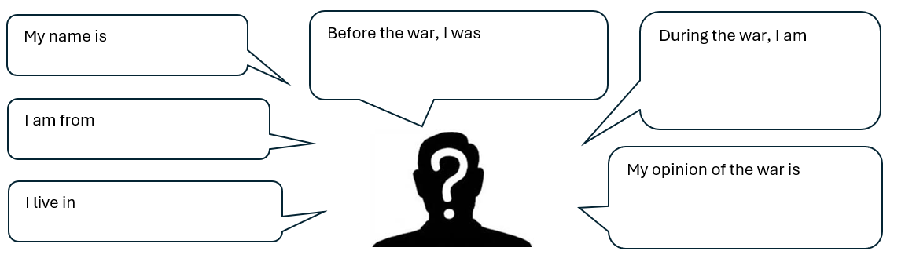
Warm-up: Who’s Who of the Texas Revolution
Unit 5: The Texas Revolution
Name: |  | Date: |  | Period:

Directions: Think of all the different types of people who lived through the Texas Revolution. Men, women, children, Anglos, Tejanos, Mexicans, enslaved people, and American Indians in Texas. Choose one point of view and complete the graphic organizer based on your choice.

Who’s Who of the Texas Revolution Exit Ticket

Directions: Complete the graphic organizer below using information about two of the people we studied in this lesson.
I think these two people . . .  (Choose 2 people and write their names below) | Probably shared similar points of view about . . .  (circle or highlight a topic below) | Because they probably both thought . . .  (explain your reasoning)
The centralist government

Texas independence

Support for the Mexican Constitution of 1824

The Texas Revolution

Other _____________________________

Who’s Who of the Texas Revolution Exit Ticket

Directions: Complete the graphic organizer below using information about two of the people we studied in this lesson.
I think these two people . . .  (Choose 2 people and write their names below) | Probably shared similar points of view about . . .  (circle or highlight a topic below) | Because they probably both thought . . .  (explain your reasoning)
The centralist government

Texas independence

Support for the Mexican Constitution of 1824

The Texas Revolution

Other _____________________________

